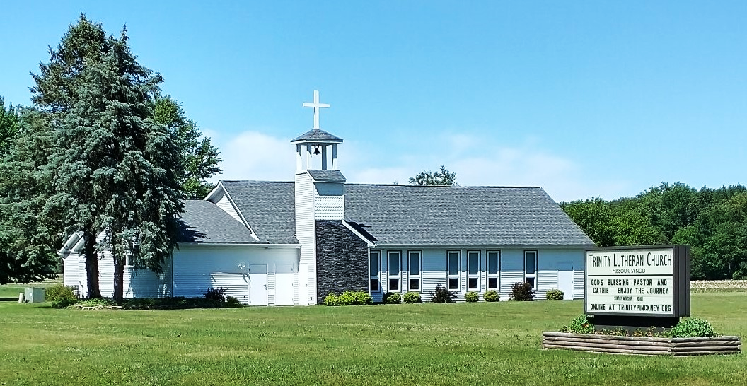
May10, 2026
The Dove
Weekly
Trinity Lutheran, Pinckney
Official Announcements
Accept no Substitutes

VOTERS ASSEMBLY May 17 after worship
Save the Date. We will be voting for Officers.
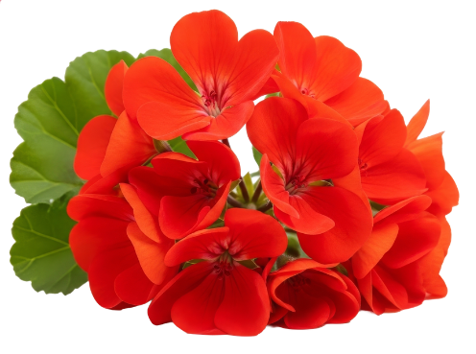
We will again be adorning the altar with red geraniums for Pentecost. Cost is $10 each and order forms need to be turned in to Barb Yek by Sunday, May 17. They can be taken home after the worship service or leave them to be planted around the sign in front. Thank you

TUESDAY MORNING: God's Word is our source for Life. Through deeper study of the Gospel of John, we will see the bigger picture of God's plan for our lives. If you crave more intentional, comprehensible, and practical application study of God's Word, you will appreciate the Life by His Word study of the Gospel of John. Whether you are new to the church, a life-long member, or studying on your own, this study will connect you with the full story of God's work in your life and lead you to see His promises anew. Each lesson is divided into easy-to-use one-page handouts. Join us on Tuesday mornings at 10:00!

CHARTING OUR COURSE
Attendance week of May 3, 2026
10:00 am Worship in Person: 62/Online plays: 111
Communion: 54
9:00 am Kids Sunday school In Person: 5
9:00 am Adult Bible Class in Person: 16/Online plays: 153

WORSHIP SERVANTS May 10, 2026

Acolyte: Sam Ratliff
Elders: Garet Fix
Pastor: Pastor Ken Huner
Organist: Daniel Eppler
Special Music:
Altar: Barb Yek and Athena Reister
Counting: Bryan Bickle and Greg Eppler
Ushers: Dennis and Stacy Sprague
Greeters: Jim and Penny Myers

MINISTRY CALENDAR FOR THE WEEK
Sun May 10
Thurs May 14
10:30 am – Christian Art Class
7 pm – Elders
Fri May 15
Sat May 16
Sun May 17
9 am – Adult Bible Study Matthew
9 am – Children’s Sunday School
10 am – Seventh Sunday of Easter
VOTERS MEETING AFTER WORSHIP
9 am – Adult Bible Study Matthew
9 am – Children’s Sunday School
10 am – Sixth Sunday of Easter
Mon May 11
4:30 pm -- Confirmation
Tues May 12
10 am -- Adult Bible Study
11 qm -- Prayer Warriors

Wed May 13

OFFICE PERSONNEL CONFERENCE
On April 26 – 28 I attended the Office Personnel Conference in Frankenmuth at the Bavarian Inn. With me were St. Paul personnel, Office Admin Deb Pugh, and Staff Secretary Diane McGinnis. Aside from having a good time, we were refreshed and uplifted in devotions, song, and worship. Whether in a breakout session or general talk, all of us share what we have learned through the years: how we resolved program issues, talking to people who walk through the door, being an ear to listen and comfort when they need someone to talk to if the pastor or deconess is not available at that moment.
We were blessed with many really good breakout sessions.
I attended a breakout by Julie Bellamy called The Power of Active Listening. In this class, we worked in pairs, discussing some of the things on our minds regarding our offices, taking turns being the listener. It was helpful to pay attention to how we listen to each other and how to do it better.
I also attended a communication talk on how and where we may be headed next in the future of digital and how we connect efficiently with our congregations through email, and some newer programs that are out there now.
After that was the Life of Harmony, which I have to admit
I attended partly because Rev. Travis Gulke was the speaker, who is Rev. Gavin Gulke’s son. Rev Gavin has been our guest pastor a few times at Trinity so it was interesting to hear Travis speak about remember what your important obligations are first and to make sure they stay in balance with each other.
The last session was Beyond the Breakwater, new ideas for an old outreach. The concept is based on the fact that many people want to do for themselves and don’t want just handouts, but needing help for less. The session talked about a program started at Messiah Lutheran church in Midland. It’s a very interesting concept and is working quite well for its founding church. You can listen to their podcast here
https://www.elevatemidland.org/beyondthebreakwater
Of course, there was awesome Bavarian Inn food, and the mini Danish at breakfast were obviously made there.
Wonderful entertainment, devotions, and keynote speakers.
Blessings to you
Lynda Minger

