Trinity Lutheran Church, LCMS
5758 W. M36, Pinckney MI 48169
www.trinitypinckney.org
(734) 878.5977
Pastor Ken Huner

4th Sunday in
Lent

March 15, 2026

Divine Service 1

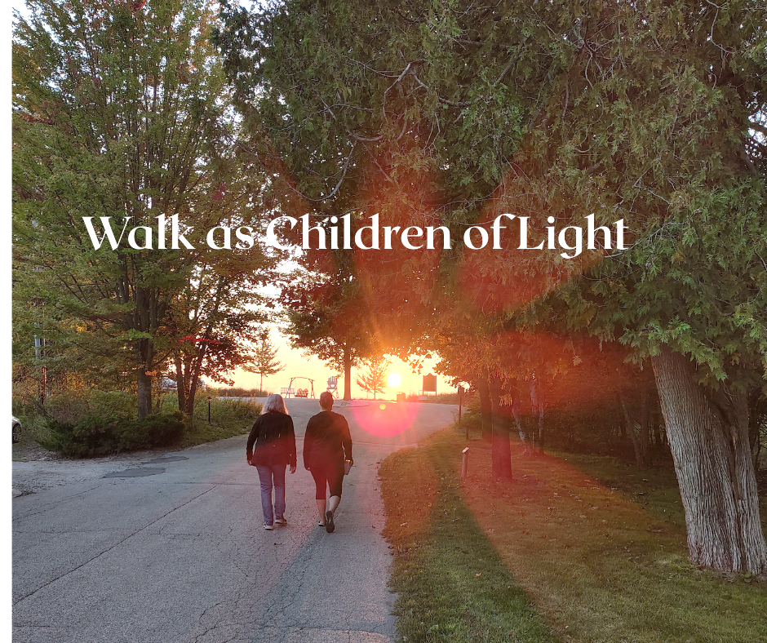

PRESERVICE ANNOUNCEMENTS
PROCESSIONAL

AS WE GATHER
By His Word of the Gospel, Jesus Calls Us Out of the Darkness into His Marvelous Light
The Lord is grieved by the spiritual blindness of His people, yet in mercy He does not forsake them. He restrains His anger and keeps His peace, until He opens their ears and eyes to hear and see Him (Isaiah 42:21). Jesus turns “the darkness before them into light” (Isaiah 42:16) because He is “the light of the world” (John 9:5). The incarnate Son of God does the works of His Father and displays the divine glory in His own flesh (John 9:4). By the washing of water with His Word, He opens the eyes of the blind and grants rest to the weary. Therefore, though “at one time you were darkness,” now “you are light in the Lord” (Ephesians 5:8). By our Baptism into Christ, we live in the eternal day of His resurrection, wherein He shines upon us, empowering us to Walk As Children of the Light.

HYMN OF INVOCATION: 902 Lord Jesus Christ, Be Present Now
1 Lord Jesus Christ, be present now;
Our hearts in true devotion bow.
Your Spirit send with light divine,
And let Your truth within us shine.

2 Unseal our lips to sing Your praise
In endless hymns through all our days.
Increase our faith and light our minds;
And set us free from doubt that blinds.

3 Then shall we join the hosts that cry,
“O holy, holy Lord Most High!”
And in the light of that blest place
We then shall see You face to face.

D 4 All glory to the Father, Son,
And Holy Spirit, Three in One!
To You, O blessèd Trinity,
Be praise throughout eternity!
Text: Lutherisch Hand-Büchlein, 1648, Altenburg; tr. Catherine Winkworth, 1827–78, alt.
Text: Public domain

Stand

The sign of the cross may be made by all in remembrance of their Baptism.

INVOCATION
P In the name of the Father and of the T Son and of the Holy Spirit.
C Amen.

EXHORTATION LSB 151
P If we say we have no sin, we deceive ourselves, and the truth is not in us.
C But if we confess our sins, God, who is faithful and just, will forgive our sins and cleanse us from all unrighteousness.

Kneel/Stand

Silence for reflection on God’s Word and for self-examination.

CONFESSION OF SINS LSB 151
P Let us then confess our sins to God our Father.
C Most merciful God, we confess that we are by nature sinful and unclean. We have sinned against You in thought, word, and deed, by what we have done and by what we have left undone. We have not loved You with our whole heart; we have not loved our neighbors as ourselves. We justly deserve Your present and eternal punishment. For the sake of Your Son, Jesus Christ, have mercy on us. Forgive us, renew us, and lead us, so that we may delight in Your will and walk in Your ways to the glory of Your holy name. Amen.

ABSOLUTION LSB 151
P Almighty God in His mercy has given His Son to die for you and for His sake forgives you all your sins. As a called and ordained servant of Christ, and by His authority, I therefore forgive you all your sins in the name of the Father and of the T Son and of the Holy Spirit.
C Amen.

Stand

Service of the Word

INTROIT
P My eyes are ever toward the Lord,
for he will pluck my feet out of the net.
C One thing have I asked of the Lord, that will I seek after:
that I may dwell in the house of the Lord all the days of my life, to gaze upon the beauty of the Lord and to inquire in his temple.
P For he will hide me in his shelter in the day of trouble;
he will conceal me under the cover of his tent; he will lift me high upon a rock.
C And now my head shall be lifted up above my enemies all around me, and I will offer in his tent sacrifices with shouts of joy;
I will sing and make melody to the Lord.
Glory be to the Father and to the Son
and to the Holy Spirit;
as it was in the beginning,
is now, and will be forever. Amen.
P My eyes are ever toward the Lord,
for he will pluck my feet out of the net.

KYRIE LSB 152
P In peace let us pray to the Lord.
C Lord, have mercy.
P For the peace from above and for our salvation let us pray to the Lord.
C Lord, have mercy.
P For the peace of the whole world, for the well-being of the Church of God, and for the unity of all let us pray to the Lord.
C Lord, have mercy.
P For this holy house and for all who offer here their worship and praise let us pray to the Lord.
C Lord, have mercy.
P Help, save, comfort, and defend us, gracious Lord.
C Amen.

SALUTATION AND COLLECT OF THE DAY
P The Lord be with you.

Let us pray.
Almighty God, our heavenly Father, Your mercies are new every morning; and though we deserve only punishment, You receive us as Your children and provide for all our needs of body and soul. Grant that we may heartily acknowledge Your merciful goodness, give thanks for all Your benefits, and serve You in willing obedience; through Jesus Christ, Your Son, our Lord, who lives and reigns with You and the Holy Spirit, one God, now and forever.
C Amen

Sit

OLD TESTAMENT Isaiah 42:14-21
Israel's Failure to Hear and See
14For a long time I have held my peace;
I have kept still and restrained myself;
now I will cry out like a woman in labor;
I will gasp and pant.
15I will lay waste mountains and hills,
and dry up all their vegetation;
I will turn the rivers into islands,
and dry up the pools.
16And I will lead the blind
in a way that they do not know,
in paths that they have not known
I will guide them.
I will turn the darkness before them into light,
the rough places into level ground.
These are the things I do,
and I do not forsake them.
17They are turned back and utterly put to shame,
who trust in carved idols,
who say to metal images,
“You are our gods.”
Israel’s Failure to Hear and See
18Hear, you deaf,
and look, you blind, that you may see!
19Who is blind but my servant,
or deaf as my messenger whom I send?
Who is blind as my dedicated one,
or blind as the servant of the Lord?
20He sees many things, but does not observe them;
his ears are open, but he does not hear.
21The Lord was pleased, for his righteousness’ sake,
to magnify his law and make it glorious.

P This is the Word of the Lord.
C Thanks be to God.

EPISTLE Ephesians 5:8-14
8For at one time you were darkness, but now you are light in the Lord. Walk as children of light 9(for the fruit of light is found in all that is good and right and true), 10and try to discern what is pleasing to the Lord. 11Take no part in the unfruitful works of darkness, but instead expose them. 12For it is shameful even to speak of the things that they do in secret. 13But when anything is exposed by the light, it becomes visible, 14for anything that becomes visible is light. Therefore it says,
“Awake, O sleeper,
and arise from the dead,
and Christ will shine on you.”

P This is the Word of the Lord.
C Thanks be to God.

Stand

VERSE LSB 157
C Return to the Lord, your God, for He is gracious and merciful, slow to anger, and abounding in steadfast love, and abounding in steadfast love.

GOSPEL John 9:1–7, 13–17, 34–39
P The Holy Gospel according to St. John, the ninth chapter.
C Glory to You, O Lord.

Jesus Heals a Man Born Blind
1As [Jesus] passed by, he saw a man blind from birth. 2And his disciples asked him, “Rabbi, who sinned, this man or his parents, that he was born blind?” 3Jesus answered, “It was not that this man sinned, or his parents, but that the works of God might be displayed in him. 4We must work the works of him who sent me while it is day; night is coming, when no one can work. 5As long as I am in the world, I am the light of the world.” 6Having said these things, he spat on the ground and made mud with the saliva. Then he anointed the man’s eyes with the mud 7and said to him, “Go, wash in the pool of Siloam” (which means Sent). So he went and washed and came back seeing. . . .
13They brought to the Pharisees the man who had formerly been blind. 14Now it was a Sabbath day when Jesus made the mud and opened his eyes. 15So the Pharisees again asked him how he had received his sight. And he said to them, “He put mud on my eyes, and I washed, and I see.” 16Some of the Pharisees said, “This man is not from God, for he does not keep the Sabbath.” But others said, “How can a man who is a sinner do such signs?” And there was a division among them. 17So they said again to the blind man, “What do you say about him, since he has opened your eyes?” He said, “He is a prophet.” . . .
34They answered him, “You were born in utter sin, and would you teach us?” And they cast him out.
35Jesus heard that they had cast him out, and having found him he said, “Do you believe in the Son of Man?” 36He answered, “And who is he, sir, that I may believe in him?” 37Jesus said to him, “You have seen him, and it is he who is speaking to you.” 38He said, “Lord, I believe,” and he worshiped him. 39Jesus said, “For judgment I came into this world, that those who do not see may see, and those who see may become blind.”

P This is the Gospel of the Lord.
C Praise to You, O Christ.

Sit

HYMN OF THE DAY: 688 “Come, Follow Me,” The Savior Spake
1 “Come, follow Me,” the Savior spake,
“All in My way abiding;
Deny yourselves, the world forsake,
Obey My call and guiding.
O bear the cross, whate’er betide,
Take My example for your guide.

2 “I am the light, I light the way,
A godly life displaying;
I bid you walk as in the day;
I keep your feet from straying.
I am the way, and well I show
How you must sojourn here below.
3 “My heart abounds in lowliness,
My soul with love is glowing;
And gracious words My lips express,
With meekness overflowing.
My heart, My mind, My strength, My all,
To God I yield, on Him I call.

4 “I teach you how to shun and flee
What harms your soul’s salvation,
Your heart from ev’ry guile to free,
From sin and its temptation.
I am the refuge of the soul
And lead you to your heav’nly goal.”

5 Then let us follow Christ, our Lord,
And take the cross appointed
And, firmly clinging to His Word,
In suff’ring be undaunted.
For those who bear the battle’s strain
The crown of heav’nly life obtain.
Text: tr. Charles W. Schaeffer, 1813–96; (sts. 1–3, 5): Johann Scheffler, 1624–77; (st. 4): Geistliche Lieder und Lobgesänge, 1695
Text: Public domain

SERMON: Walk As Children of the Light!

Stand

NICENE CREED
C I believe in one God,
the Father Almighty,
maker of heaven and earth
and of all things visible and invisible.

And in one Lord Jesus Christ,
the only-begotten Son of God,
begotten of His Father before all worlds,
God of God, Light of Light,
very God of very God,
begotten, not made,
being of one substance with the Father,
by whom all things were made;
who for us men and for our salvation came down from heaven
and was incarnate by the Holy Spirit of the virgin Mary
and was made man;
and was crucified also for us under Pontius Pilate.
He suffered and was buried.
And the third day He rose again according to the Scriptures
and ascended into heaven
and sits at the right hand of the Father.
And He will come again with glory to judge both the living and the dead,
whose kingdom will have no end.

And I believe in the Holy Spirit,
the Lord and giver of life,
who proceeds from the Father and the Son,
who with the Father and the Son together is worshiped and glorified,
who spoke by the prophets.
And I believe in one holy Christian and apostolic Church,
I acknowledge one Baptism for the remission of sins,
and I look for the resurrection of the dead
and the life T of the world to come. Amen.

PRAYER OF THE CHURCH
P Almighty God – Light of the world, oh, how we need You to enlighten Your warped world wrapped in war. We pray for the safety for our soldiers, and for innocent civilians everywhere, and pray that You would shine Your wisdom into the hearts and minds of our country’s leaders and leaders around the world to work together for compromise and strive for peace.
C Almighty God, You are the Light of the world and have called us out of darkness and into Your marvelous light and have commissioned us to let our lights shine so others see our good deeds and give glory to You, our Father in heaven.

P By Your Light of Life, rule and govern our hearts and lives and Your whole Church throughout the world that those in leadership roles would be guided and directed by You in their ministry; and for all vacant congregations, that You would send laborers into Your harvest and that all those who proclaim Your saving Word do so in all truth and purity so that faith and love are strengthened and increased in all Your people. We give You thanks for Your liberating Word made known especially in the light shining through the glorious cross of Your Son, our Lord and Savior Jesus Christ.
C Through Your Word enlighten our hearts and minds now that we may keep our lives shining and bring forth the fruits of faith in all that we say and do. We commend to You the care of our schools so that our children grow in the grace and knowledge of Jesus, our Lord of Light, that they and we – Walk As Children of the Light.

P Comfort all who are dealing with trials, sickness, grief, or any other adversity. (Special prayers offered) Grant courage and strength to all that they would take heart, trusting in Christ for healing and find Him even in the midst of their suffering and trials, for He is our ever-present help, our Refuge and Strength in every situation and circumstance.
C And help us – Lord of Light, to prepare for the world to come, doing the work You have given us to do while it is day before the night comes when no one can work. And for the faith to believe Christ’s blessed promises, to come to His Holy Supper for the assurance of His forgiveness of our sins, and to confess His truths with honest hearts in the communion at the altar, we thank and praise You, our Lord of Light.

P All these things, O heavenly Father, we pray in the name of Jesus Christ, asking You to grant our prayers not for our sake but for His sake alone. Teach our hearts to be content with Your will and to trust that You will answer with what is best for us and at the right time for our need.
C Graciously receive our prayers, deliver and preserve us, for to You alone we give all glory, honor and worship – Father, Son and Holy Spirit, one God, now and forever. Amen.
Sit

OFFERING

Stand

OFFERTORY LSB 159
C What shall I render to the Lord for all His benefits to me?
I will offer the sacrifice of thanksgiving and will call on the name of the Lord.
I will take the cup of salvation and will call on the name of the Lord.
I will pay my vows to the Lord now in the presence of all His people,
in the courts of the Lord’s house, in the midst of you, O Jerusalem.
Service of the Sacrament

PREFACE LSB 160
P The Lord be with you.
C And also with you.

P Lift up your hearts.
C We lift them to the Lord.

P Let us give thanks to the Lord our God.
C It is right to give Him thanks and praise.

PROPER PREFACE (ABBREVIATED) LSB 161
P It is truly good, right, and salutary . . . evermore praising You and saying:

SANCTUS LSB 161
C Holy, holy, holy Lord God of pow’r and might:
Heaven and earth are full of Your glory.
Hosanna. Hosanna.
Hosanna in the highest.
Blessed is He who comes in the name of the Lord.
Hosanna in the highest.

PRAYER OF THANKSGIVING LSB 161
P Blessed are You, Lord of heaven and earth, for You have had mercy on those whom You created and sent Your only-begotten Son into our flesh to bear our sin and be our Savior. With repentant joy we receive the salvation accomplished for us by the all-availing sacrifice of His body and His blood on the cross.

Gathered in the name and the remembrance of Jesus, we beg You, O Lord, to forgive, renew, and strengthen us with Your Word and Spirit. Grant us faithfully to eat His body and drink His blood as He bids us do in His own testament. Gather us together, we pray, from the ends of the earth to celebrate with all the faithful the marriage feast of the Lamb in His kingdom, which has no end. Graciously receive our prayers; deliver and preserve us. To You alone, O Father, be all glory, honor, and worship, with the Son and the Holy Spirit, one God, now and forever.
C Amen.

PROCLAMATION OF CHRIST
P As often as we eat this bread and drink this cup, we proclaim the Lord’s death until He comes.
C Amen. Come, Lord Jesus.

P O Lord Jesus Christ, only Son of the Father, in giving us Your body and blood to eat and to drink, You lead us to remember and confess Your holy cross and passion, Your blessed death, Your rest in the tomb, Your resurrection from the dead, Your ascension into heaven, and Your coming for the final judgment. So remember us in Your kingdom and teach us to pray:

LORD’S PRAYER
C Our Father who art in heaven,
hallowed be Thy name,
Thy kingdom come,
Thy will be done on earth
as it is in heaven;
give us this day our daily bread;
and forgive us our trespasses
as we forgive those
who trespass against us;
and lead us not into temptation,
but deliver us from evil.
For Thine is the kingdom
and the power and the glory
forever and ever. Amen.

PAX DOMINI LSB 163
P The peace of the Lord be with you always.
C Amen.

AGNUS DEI LSB 163
C Lamb of God, You take away the sin of the world; have mercy on us.
Lamb of God, You take away the sin of the world; have mercy on us.
Lamb of God, You take away the sin of the world; grant us peace.
Sit

DISTRIBUTION

DISTRIBUTION HYMN: 496 Holy Spirit, Light Divine
1 Holy Spirit, light divine,
Shine upon this heart of mine;
Chase the shades of night away,
Turn the darkness into day.

2 Let me see my Savior’s face,
Let me all His beauties trace;
Show those glorious truths to me
Which are only known to Thee.

3 Holy Spirit, pow’r divine,
Cleanse this guilty heart of mine;
In Thy mercy pity me,
From sin’s bondage set me free.

4 Holy Spirit, joy divine,
Cheer this saddened heart of mine;
Yield a sacred, settled peace,
Let it grow and still increase.

5 Holy Spirit, all divine,
Dwell within this heart of mine;
Cast down ev’ry idol throne,
Reign supreme, and reign alone.
Text: Andrew Reed, 1787–1862, alt.
Text: Public domain
DISTRIBUTION HYMN: 913 O Holy Spirit, Enter In
1 O Holy Spirit, enter in,
And in our hearts Your work begin,
Your dwelling place now make us.
Sun of the soul, O Light divine,
Around and in us brightly shine,
To joy and gladness wake us
That we may be
Truly living,
To You giving
Prayer unceasing
And in love be still increasing.

2 Give to Your Word impressive pow’r,
That in our hearts from this good hour
As fire it may be glowing,
That in true Christian unity
We faithful witnesses may be,
Your glory ever showing.
Hear us, cheer us
By Your teaching;
Let our preaching
And our labor
Praise You, Lord, and serve our neighbor.

3 O mighty Rock, O Source of life,
Let Your dear Word, in doubt and strife,
In us be strongly burning
That we be faithful unto death
And live in love and holy faith,
From You true wisdom learning.
Your grace and peace
On us shower;
By Your power
Christ confessing,
Let us see our Savior’s blessing.
Text: Michael Schirmer, 1606–73, adapt.; (sts. 1, 3): tr. Catherine Winkworth, 1827–78, alt.; (st. 2): tr. The Lutheran Hymnal, 1941, alt.
Text: Public domain

Stand

NUNC DIMITTIS LSB 165
C Lord, now You let Your servant go in peace; Your word has been fulfilled.
My own eyes have seen the salvation which You have prepared in the sight of ev’ry people:
A light to reveal You to the nations and the glory of Your people Israel.
Glory be to the Father and to the Son and to the Holy Spirit;
as it was in the beginning, is now, and will be forever. Amen.

POST-COMMUNION COLLECT
P Let us pray.
We give thanks to You, almighty God, that You have refreshed us through this salutary gift, and we implore You that of Your mercy You would strengthen us through the same in faith toward You and in fervent love toward one another; through Jesus Christ, Your Son, our Lord, who lives and reigns with You and the Holy Spirit, one God, now and forever.
C Amen.

BENEDICTION LSB 166
P The Lord bless you and keep you.
The Lord make His face shine on you and be gracious to you.
The Lord look upon you with favor and T give you peace.
C Amen.

HYMN TO DEPART: 411 I WANT TO WALK AS A CHILD OF THE LIGHT
1 I want to walk as a child of the light.
I want to follow Jesus.
God set the stars to give light to the world.
The star of my life is Jesus. Refrain

ref In Him there is no darkness at all.
The night and the day are both alike.
The Lamb is the light of the city of God.
Shine in my heart, Lord Jesus.

2 I want to see the brightness of God.
I want to look at Jesus.
Clear Sun of Righteousness, shine on my path,
And show me the way to the Father. Refrain

3 I’m looking for the coming of Christ.
I want to be with Jesus.
When we have run with patience the race,
We shall know the joy of Jesus. Refrain
Text: Kathleen Thomerson, 1934–2025
Text: © 1970, 1975 Celebration. Used by permission: LSB Hymn License no. 110002688


WELCOME, We are blessed at the return of Rev. Grulke! We are very happy to have Rev. Galen Grulke leading our worship again this Sunday while Pastor Huner and Kim are on vacation. Pastor Grulke, in retirement, serves as Visitation/Guest pastor where he is needed. We pray that we will enrich his service as he is enriching ours.

Also, pray for safe travels and good times for Pastor Ken and Kim.

COMMUNION INSTRUCTIONS
We pray that our worship blesses your day as you are blessing ours by attending.
THE LORD’S SUPPER will be celebrated during our worship service this morning. The Bible is clear about who is welcomed and prepared to receive Holy Communion. St. Paul writes in 1 Corinthians 11:28 – “Everyone ought to examine themselves before they eat of the bread and drink from the cup.” Therefore, those Christians who are prepared and “worthy”; communicants have been led by the Holy Spirit to …
1) Feel contrition and confess all sins to the LORD
2) Trust in Christ for the forgiveness of sins
3) Strive to turn away from unrepented sin and
4) Discern and believe in the real presence of Christ’s true body and blood in, with and under the outward forms of bread and wine. Therefore, we welcome all confirmed adults to join us at the Table of the Lord. We do invite those adults and children who are not prepared to receive the Lord’s Supper to come to the communion table, cross your arms across your heart, and receive a blessing from the pastor. Thank you!

