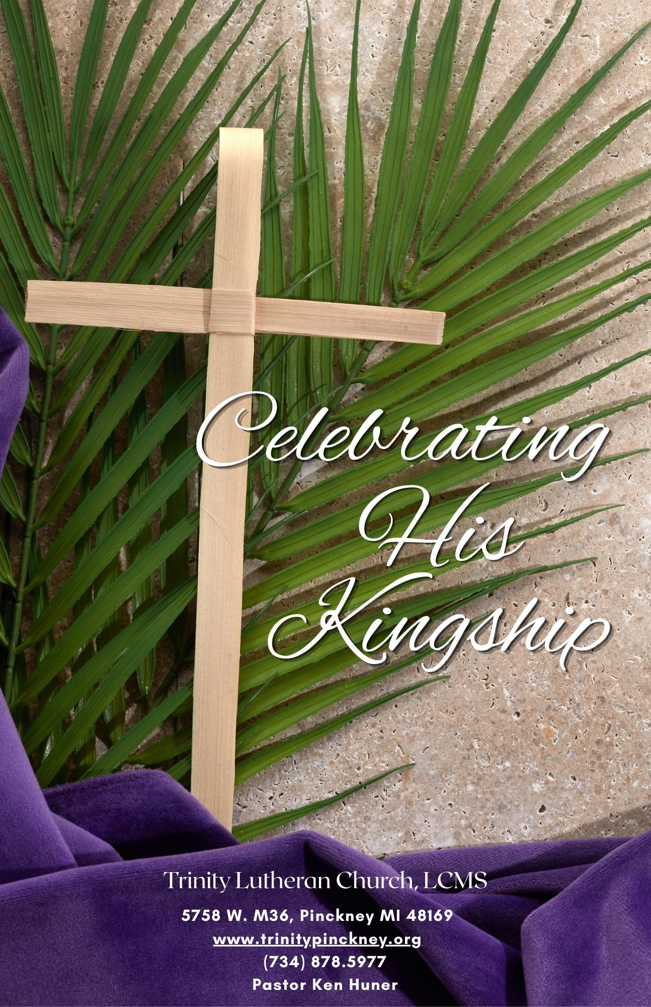

PRE-SERVICE ANNOUNCEMENTS

AS WE GATHER (In the narthex)
Today we enter the Great and Holy Week of our faith, the very heart and center of God’s greatest act since the Creation itself—the salvation of mankind by the overthrow of sin, death, and the devil, and the restoration of all creation through the power of the resurrection of the dead and the life of the world to come. As we join the crowds welcoming Jesus, the one who comes in the name of the Lord, we plan to get swept up in the drama of the story many know so well.

Peter wrote, “Therefore, preparing your minds for action, and being sober-minded, set your hope fully on the grace that will be brought to you at the revelation of Jesus Christ” (1 Peter 1:13). On this day “preparing [our] minds for action” makes us as contemplate and consider what was in the mind of Jesus as He entered Jerusalem to the cheers of adults and children waving palms and shouting praise. What was our Lord thinking as He gathered His disciples for the Last Supper of Passover? As He prayed in Gethsemane’s garden? When He was arrested, falsely tried, beaten, abused, and sentenced to death by crucifixion? What was in the Savior’s mind as He hung on that cross? For the obvious impossibility of our ability to know the depths of the God who says, “My thoughts are not your thoughts, neither are your ways My ways” (Isaiah 55:8), there is one thing we can know for sure—He had you in mind. We know that “God so loved the world” (John 3:16).

PREPARATION

GREETING
P The grace of our Lord T Jesus Christ and the love of God and the communion of the Holy Spirit be with you all.
C Amen.

P Blessed is He who comes in the name of the Lord.
C Hosanna to the Son of David.

COLLECT
P Let us pray.
Lord God, as the people in Jerusalem gathered to welcome Your Son, our Lord, when He came into His holy city, so we sing of Your coming among us today with songs of praise. Keep us steadfast in our hope and confession of faith throughout our lives that we may meet Him with grateful hearts when He comes again in glory; through the same Jesus Christ, our Lord, who lives and reigns with You and the Holy Spirit, one God, now and forever.
C Amen. Blessed is He who comes in the name of the Lord.

PROCESSIONAL GOSPEL Matthew 21:1–11
P The Holy Gospel according to St. Matthew, the twenty-first chapter.
C Glory to You, O Lord.

The Triumphal Entry
¹Now when they drew near to Jerusalem and came to Bethphage, to the Mount of Olives, then Jesus sent two disciples, ²saying to them, “Go into the village in front of you, and immediately you will find a donkey tied, and a colt with her. Untie them and bring them to me. ³If anyone says anything to you, you shall say, ‘The Lord needs them,’ and he will send them at once.” ⁴This took place to fulfill what was spoken by the prophet, saying,

⁵“Say to the daughter of Zion,
‘Behold, your king is coming to you,
humble, and mounted on a donkey,
and on a colt, the foal of a beast of burden.’”

⁶The disciples went and did as Jesus had directed them. ⁷They brought the donkey and the colt and put on them their cloaks, and he sat on them. ⁸Most of the crowd spread their cloaks on the road, and others cut branches from the trees and spread them on the road. ⁹And the crowds that went before him and that followed him were shouting, “Hosanna to the Son of David! Blessed is he who comes in the name of the Lord! Hosanna in the highest!” ¹⁰And when he entered Jerusalem, the whole city was stirred up, saying, “Who is this?” ¹¹And the crowds said, “This is the prophet Jesus, from Nazareth of Galilee.”
P The Gospel of the Lord.
C Praise to You, O Christ.

P Let us go forth in peace,
C in the name of the Lord.
Processional led by Acolytes. Congregation files in singing and waving their palms. Palms are put in the pots as they pass and proceed to their seats.

HYMN: 442 ALL GLORY, LAUD, AND HONOR

Refrain All glory, laud, and honor
To You, Redeemer, King,
To whom the lips of children
Made sweet hosannas ring.

1 You are the King of Israel
And David’s royal Son,
Now in the Lord’s name coming,
Our King and Blessèd One. Refrain

2 The company of angels
Is praising You on high,
And we with all creation
In chorus make reply. Refrain

3 The multitude of pilgrims
With palms before You went;
Our praise and prayer and anthems
Before You we present. Refrain

4 To You before Your passion
They sang their hymns of praise;
To You, now high exalted,
Our melody we raise. Refrain

5 As You received their praises,
Accept the prayers we bring,
O Source of ev’ry blessing,
Our good and gracious King. Refrain
Text: Theodulf of Orléans, c. 762–821; tr. John Mason Neale, 1818–66, alt.
Text: Public domain

When all have arrived at their place, the procession concludes:

GREETING
P Blessed is He who comes in the name of the Lord.
C Hosanna in the highest.

PRAYER OF THE DAY
P Let us pray.
Almighty and everlasting God, You sent Your Son, our Savior Jesus Christ, to take upon Himself our flesh and to suffer death upon the cross. Mercifully grant that we may follow the example of His great humility and patience and be made partakers of His resurrection; through the same Jesus Christ, our Lord, who lives and reigns with You and the Holy Spirit, one God, now and forever.
C Amen.

WORD

OLD TESTAMENT Isaiah 50:4–9a
4The Lord God has given me
the tongue of those who are taught,
that I may know how to sustain with a word
him who is weary.
Morning by morning he awakens;
he awakens my ear
to hear as those who are taught.
5The Lord God has opened my ear,
and I was not rebellious;
I turned not backward.
6I gave my back to those who strike,
and my cheeks to those who pull out the beard;
I hid not my face
from disgrace and spitting.
7But the Lord God helps me;
therefore I have not been disgraced;
therefore I have set my face like a flint,
and I know that I shall not be put to shame.
8He who vindicates me is near.
Who will contend with me?
Let us stand up together.
Who is my adversary?
Let him come near to me.
9Behold, the Lord God helps me;
who will declare me guilty?

L This is the Word of the Lord.
C Thanks be to God.

PSALM Psalm 118:19–29; antiphon: v. 26
P ¹⁹Open to me the gates of righteousness,
that I may enter through them
and give thanks to the Lord.
C ²⁰This is the gate of the Lord;
the righteous shall enter through it.
P ²¹I thank you that you have answered me
and have become my salvation.
C ²²The stone that the builders rejected
has become the cornerstone.
P ²³This is the Lord’s doing;
it is marvelous in our eyes.
C ²⁴This is the day that the Lord has made;
let us rejoice and be glad in it.

P ²⁵Save us, we pray, O Lord!
O Lord, we pray, give us success!
C ²⁶Blessèd is he who comes in the name of the Lord!
We bless you from the house of the Lord.
P ²⁷The Lord is God,
and he has made his light to shine upon us.
C Bind the festal sacrifice with cords,
up to the horns of the altar!

P ²⁸You are my God, and I will give thanks to you;
you are my God; I will extol you.
C ²⁹Oh give thanks to the Lord, for he is good;
for his steadfast love endures forever!

EPISTLE Philippians 2:5–11
5Have this mind among yourselves, which is yours in Christ Jesus, 6who, though he was in the form of God, did not count equality with God a thing to be grasped, 7but made himself nothing, taking the form of a servant, being born in the likeness of men. 8And being found in human form, he humbled himself by becoming obedient to the point of death, even death on a cross. 9Therefore God has highly exalted him and bestowed on him the name that is above every name, 10so that at the name of Jesus every knee should bow, in heaven and on earth and under the earth, 11and every tongue confess that Jesus Christ is Lord, to the glory of God the Father.

L This is the Word of the Lord.
C Thanks be to God.

VERSE Philippians 2:8b
C He humbled himself by becoming obedient to the point of death, even death on a cross.

HOLY GOSPEL John 12:12–19
P The Holy Gospel according to St. John, the twelfth chapter.
C Glory to You, O Lord.

The Triumphal Entry
¹²The next day the large crowd that had come to the feast heard that Jesus was coming to Jerusalem. ¹³So they took branches of palm trees and went out to meet him, crying out, “Hosanna! Blessed is he who comes in the name of the Lord, even the King of Israel!” ¹⁴And Jesus found a young donkey and sat on it, just as it is written,
¹⁵“Fear not, daughter of Zion;
behold, your king is coming,
sitting on a donkey’s colt!”
¹⁶His disciples did not understand these things at first, but when Jesus was glorified, then they remembered that these things had been written about him and had been done to him. ¹⁷The crowd that had been with him when he called Lazarus out of the tomb and raised him from the dead continued to bear witness. ¹⁸The reason why the crowd went to meet him was that they heard he had done this sign. ¹⁹So the Pharisees said to one another, “You see that you are gaining nothing. Look, the world has gone after him.”

P The Gospel of the Lord.
C Praise to You, O Christ.

P Let us go forth in peace,
C in the name of the Lord.

CREED Nicene Creed
C I believe in one God,
the Father Almighty,
maker of heaven and earth
and of all things visible and invisible.

And in one Lord Jesus Christ,
the only-begotten Son of God,
begotten of His Father before all worlds,
God of God, Light of Light,
very God of very God,
begotten, not made,
being of one substance with the Father,
by whom all things were made;
who for us men and for our salvation came down from heaven
and was incarnate by the Holy Spirit of the virgin Mary
and was made man;
and was crucified also for us under Pontius Pilate.
He suffered and was buried.
And the third day He rose again according to the Scriptures
and ascended into heaven
and sits at the right hand of the Father.
And He will come again with glory to judge both the living and the dead,
whose kingdom will have no end.

And I believe in the Holy Spirit,
the Lord and giver of life,
who proceeds from the Father and the Son,
who with the Father and the Son together is worshiped and glorified,
who spoke by the prophets.
And I believe in one holy Christian and apostolic Church,
I acknowledge one Baptism for the remission of sins,
and I look for the resurrection of the dead
and the life T of the world to come. Amen.

KID’S SERMON

HYMN: 438 A LAMB GOES UNCOMPLAINING FORTH

1 A Lamb goes uncomplaining forth,
The guilt of sinners bearing
And, laden with the sins of earth,
None else the burden sharing;
Goes patient on, grows weak and faint,
To slaughter led without complaint,
That spotless life to offer,
He bears the stripes, the wounds, the lies,
The mockery, and yet replies,
“All this I gladly suffer.”

2 This Lamb is Christ, the soul’s great friend,
The Lamb of God, our Savior,
Whom God the Father chose to send
To gain for us His favor.
“Go forth, My Son,” the Father said,
“And free My children from their dread
Of guilt and condemnation.
The wrath and stripes are hard to bear,
But by Your passion they will share
The fruit of Your salvation.”

3 “Yes, Father, yes, most willingly
I’ll bear what You command Me.
My will conforms to Your decree,
I’ll do what You have asked Me.”
O wondrous Love, what have You done!
The Father offers up His Son,
Desiring our salvation.
O Love, how strong You are to save!
You lay the One into the grave
Who built the earth’s foundation.

4 Lord, when Your glory I shall see
And taste Your kingdom’s pleasure,
Your blood my royal robe shall be,
My joy beyond all measure!
When I appear before Your throne,
Your righteousness shall be my crown;
With these I need not hide me.
And there, in garments richly wrought,
As Your own bride shall we be brought
To stand in joy beside You.
Text: Paul Gerhardt, 1607–76; tr. The Lutheran Hymnal, 1941, alt.
Text: © 1941 Concordia Publishing House. Used by permission: LSB Hymn License no. 110002688

SERMON "Celebrating His Kingship"
John 12:12-19 (also reference to Matthew 21:1-9).

OFFERING / OFFERTORY: 956 CREATE IN ME

1 Create in me a clean heart, O God,
and renew a right spirit within me.
Cast me not away from Thy presence;
and take not Thy Holy Spirit from me.
Restore unto me the joy of Thy salvation;
and uphold me with Thy free spirit. Amen.
Text: Psalm 51:10–12
Text: Public domain

PRAYER OF THE CHURCH
P O God, for all the joy with which the people in Jerusalem greeted Your Son that day when He entered the holy city for the final time and for all the joy we feel this day as we gather before You in praise and worship, we recall His goal that week and our great need for His accomplishment of Your will of salvation. Grant that the remembrance of His innocent suffering and death draw us nearer to You in true repentance of our sin. Give us faith that the door of mercy is still open to us with the deliverance He won on the cross, bestowing forgiveness of sin and eternal life in His name. Lord, in Your mercy,
C hear our prayer. Hosanna in the highest.

P Grant that the Good News of Your work of salvation through Your Son for the life of the world be proclaimed throughout our world today by Your holy church through faithful pastors and witnesses in every place, that many turn to You and hear Your invitation for reconciliation with You through faith in Your great goodness. Lord, in Your mercy,
C hear our prayer. Blessed is He who comes in the name of the Lord.

P Grant Your blessing and guidance to all servant-leaders in our country and in all nations, that righteousness and peace may prevail. End all conflicts or wars. Bless all institutions of learning and research. Grant success to farmers and producers of food for all. Lord, in Your mercy,
C hear our prayer and grant Your blessing.
P As we all contend with the challenges of living still in a fallen world, we pray for Your help and healing of all who are sick, injured, troubled in any way, those who are lonely or afraid, [especially . . .], and all we name in our hearts before You. [Silent prayer.] Be the strength of the weary and the great physician of soul, mind, and spirit. Lord, in Your mercy,
C hear our prayer.

P Remembering the saints that have gone before us, especially our loved ones nearest us who now rest from their labors and are with You, when our last hour comes, admit us with them into Your blessed and eternal peace and presence. Lord, in Your mercy,
C hear our prayer.

P Into Your hands, O Lord, we commend all for whom we pray, through Your Son, Jesus Christ, who lives and reigns with You and the Holy Spirit, one God, now and forever.
C Blessed is He who comes in the name of the Lord. Amen.

LORD’S PRAYER
C Our Father who art in heaven,
hallowed be Thy name,
Thy kingdom come,
Thy will be done on earth
as it is in heaven;
give us this day our daily bread;
and forgive us our trespasses
as we forgive those
who trespass against us;
and lead us not into temptation,
but deliver us from evil.
For Thine is the kingdom
and the power and the glory
forever and ever. Amen.

BENEDICAMUS
P Let us bless the Lord.
C Thanks be to God.

BENEDICTION
P The Lord bless you and keep you.
The Lord make His face shine on you and be gracious to you.
The Lord look upon you with favor and T give you peace.
C Amen.

CLOSING HYMN: 527 O SAVIOR, PRECIOUS SAVIOR

Creative Worship for the Lutheran Parish, Series A, Quarter 2.
Copyright © 2025 Concordia Publishing House. All rights reserved. Used by permission.


